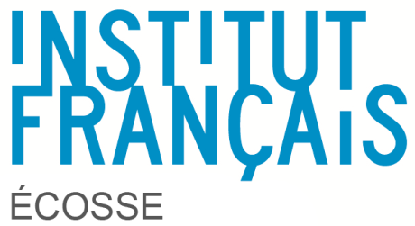
Edinburgh, 16 April 2018

RE: Grants for a one-week professional development course in France for Modern Language Development Officers, Language Leaders and teachers who have a leading role on the 1+2 policy in local authority, their cluster or their school.

Dear Sir, Madam,

The Institut français d’Écosse (IFE) is the official agency of the French Ministry of Foreign Affairs promoting French language and culture in Scotland. The IFE collaborates with Scottish education authorities to support French teaching and learning, facilitating bilateral exchanges between Scotland and France and contributing to the professional development of leaders in charge of implementing the 1+2 policy.

The IFE offers 6 grants for a one-week course in the CAVILAM, an international centre of excellence for French teachers and teachers’ trainers’ professional development receiving hundreds of participants from all over the world every summer.

The course will take place on 30 July to 3 August 2017 in Vichy. It has been designed for language leaders who have at least an A2 level in French. Participants will have the choice between various pedagogy and language workshops (see programme in appendix).

The grant includes only the course fee. All other expenses (international and national travel, accommodation, food and additional cultural activities) are of the sole responsibility of the Council, the school or the participant.

You will find hereafter an application form and a presentation of the levels of the CEFR levels, details on the programme, transport and accommodation options.

Please send your application to me by e-mail at thomas.chaurin@ifecosse.org.uk by 11 May 2018. Selected candidates will be informed on 18 May.

Do not hesitate to contact me if you need any further information.

Kind regards

Thomas Chaurin
Education Attaché

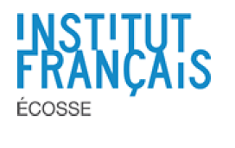
Application for a one-week course in France
First Name
Name
School
Council
E-mail
Phone
Responsibilities
Level of French
Motivations to attend this course
Morning option chosen
Afternoon option chosen
Signature | I understand that this grant includes only the course fee. All other expenses (international and national travel, accommodation, food and additional cultural activities) are of the sole responsibility of the Council, the school or the participant.  I am committed to attend all workshops and to take part actively in this week course.  Date and signature
Line manager and council signatures | For the school  Date and signature | For the council  Date and signature

